Experiment 4
Simulating a Network with Different Devices

Lab 4 Objectives:
● Simulate a network with multiple devices using network simulation software
Prerequisites: The prerequisites of this lab are
- Basic understanding of networking concepts (IP addressing, subnets, routing).
- Familiarity with network simulation tools such as Cisco Packet Tracer, GNS3, or NetSim.
- Knowledge of networking protocols (TCP/IP, ICMP, HTTP, etc.)

Outcomes: By the end of this lab, students will be able to:
- Design and configure a network topology with different types of devices.
- Assign and verify IP configurations in a simulated network environment.
- Monitor and analyze network traffic to understand data flow.

Part 1: Setting Up the Network Simulation
Step 1: Selecting Network Devices
Open Cisco Packet Tracer.
Drag and drop the following devices:
- 1 Router (Router-PT)
- 1 Switch (2960 Switch)
- 2 PCs (PC0, PC1)
- 1 Server
Step 2: Establishing Network Connections
Use Copper Straight-Through cables to connect:
- PC0 to Switch (FastEthernet0/2)
- PC1 to Switch (FastEthernet0/3)
- Server to Switch (FastEthernet0/4)
Use Copper Straight-Through cable to connect Switch to Router:
Switch FastEthernet0/1 to Router GigabitEthernet0/0
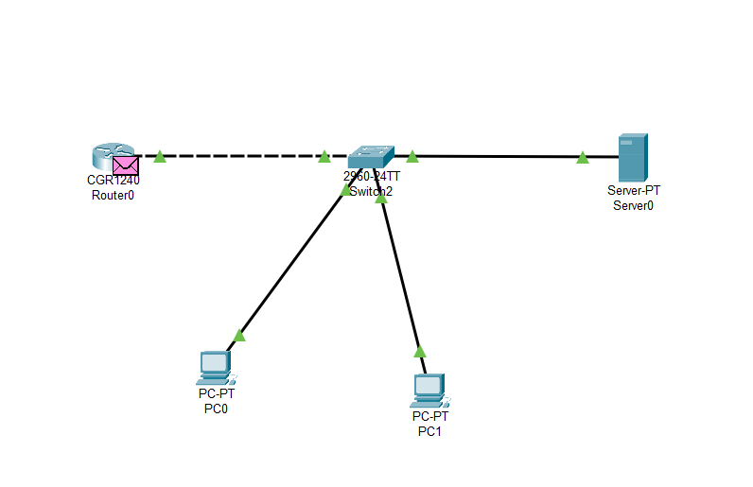

Part 2: Configuring IP Addresses
Step 1: Assigning IPs to End Devices
Device | IP Address | Subnet Mask
PC0 | 192.168.1.10 | 255.255.255.0
PC1 | 192.168.1.11 | 255.255.255.0
Server | 192.168.1.20 | 255.255.255.0

Step 2: Configuring Router Interfaces
- Access the router CLI and enter the following commands:
Router> enable
Router# configure terminal
Router(config)# interface GigabitEthernet0/0
Router(config-if)# ip address 192.168.1.1 255.255.255.0
Router(config-if)# no shutdown
Router(config-if)# exit
Router(config)# exit
Router# write memory

Part 3: Verifying Network Configuration
Step 1: Testing Network Connectivity
- From PC0, open the command prompt and ping PC1:
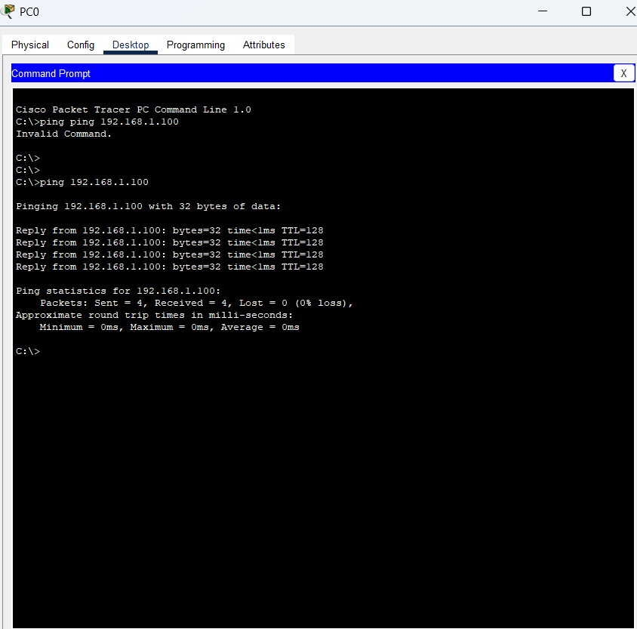

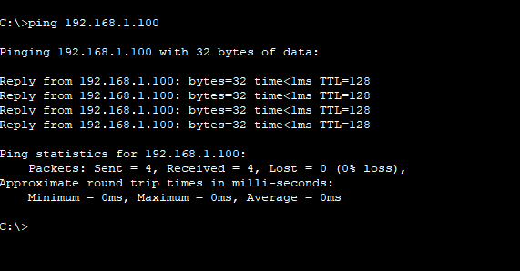
From PC1, ping the Server:

Part 4: Analyzing Data Flow
Step 1: Capturing Network Traffic
To capture network traffic, we use tools like Wireshark or the simulation mode of Cisco Packet Tracer.
- Wireshark is a widely used packet analyzer that captures and analyzes real network traffic.
- Cisco Packet Tracer's simulation mode allows us to view packet flow within a virtual network.
Process of capturing packets:
- Initiate data transfer between network devices (for example, by using the ping command).
- Packets are captured by Wireshark or the Packet Tracer simulation tool.
- By applying filters, we can view only specific protocol packets, such as ICMP.
Filtering ICMP packets:
ICMP is the protocol used for ping requests and replies. By typing icmp in the filter bar, only ping-related packets will be displayed.
This process helps us analyze network traffic to understand data flow and verify network connectivity.

Step 2: Tracing Data Flow
- From PC0 command prompt, use traceroute to PC1:
